1. When firms gain great market power, market may fail to produce an efficient outcome, as known as inefficiency. In this case, sources are not input into their best use and the social total benefits declines. There are various kinds of inefficiency: allocative inefficiency, productive inefficiency, dynamic inefficiency and so on.

First of all, allocative inefficiency occurs when consumes are not paying the marginal cost of production. On other words, goods are overpaid by consumers because of firms are intentionally producing less to gain extra profits. Firms are only able to raise the price by decreasing production when they have market power, for example, when there are monopoly or oligopolies.

Secondly, productive inefficiency occurs when firms are not producing at its lowest average cost. It means that firms could have used a lower cost to produce goods but they did not. Thus the production process is not in the most efficient stage that firms could reach. Such case also appears when firms have market power so they choose to produce in the quantity which maximizes their profits but not minimizes the average cost.

Finally dynamic inefficiency occurs when firms have no incentive to be technologically progressive. Firms can innovate in either inventing new production methods or producing new products by use of technology. However, when firms expect to have a big market share and no competitors are able to compete with them, they will spend less in innovation, research and development. As a result, in the long run, society will have higher production costs and less choice for consumers, which leads to the dynamic inefficiency.

7. I selected the market of wireless telecommunication carriers in U.S. in 2011 as my object. The major supplies are Verizon Wireless, AT&T Inc, Sprint Nextel Corporation, T-Mobile USA and other suppliers. Their market share graph is following:

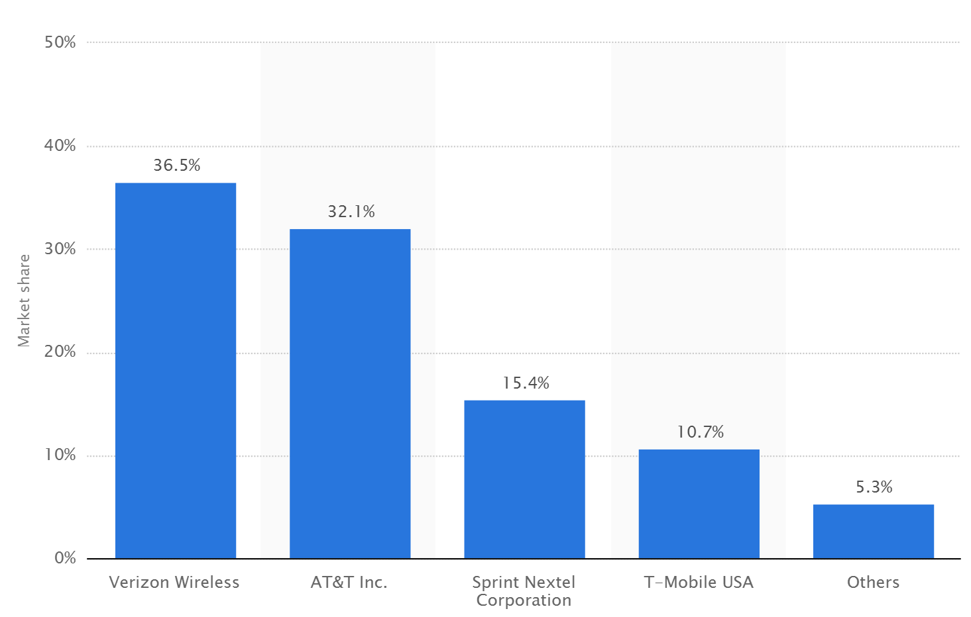

The HHI index(considering others as a whole) is 0.27424.

The 4-firm concentration ratio is 0.947 or 94.7%.